Khoa Tran

07/14/2020

EE 271

Lab 3 Milestone

1. The commented code for the ‘1101’ sequence detector

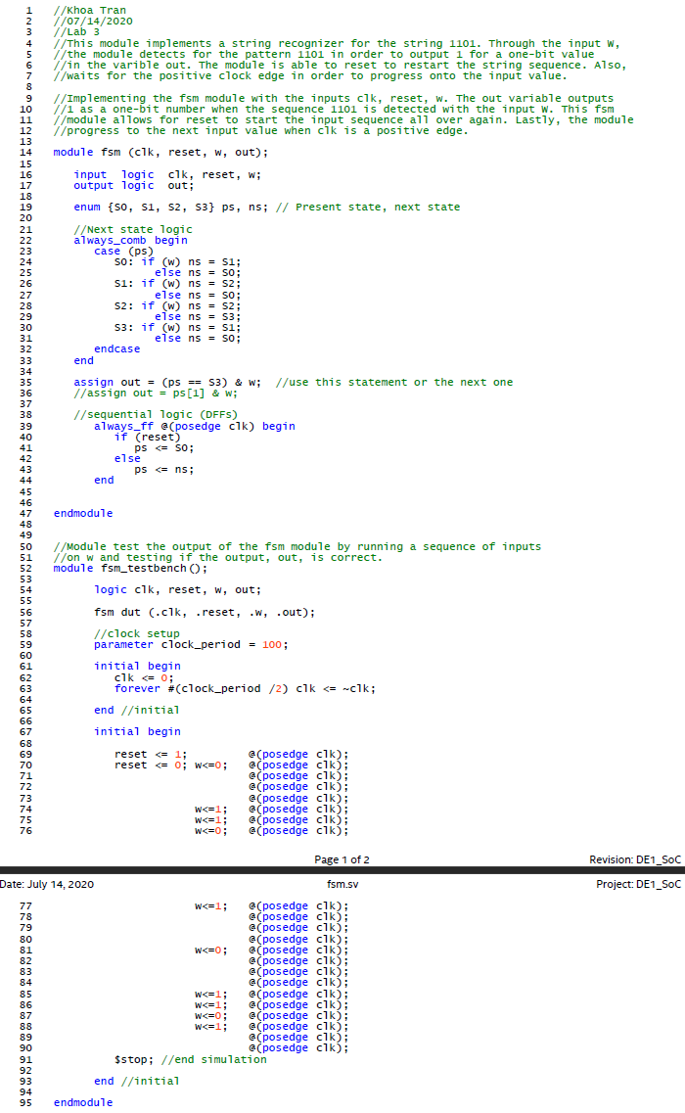

1. The state diagram for the ‘1101’ sequence detector

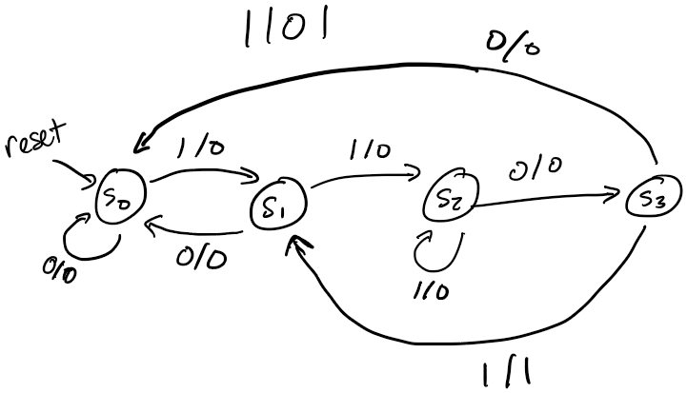

1. Simulation screenshot

Part 1 (101)

Part 2 (1101)

